**Please follow below steps to set browser compatibility**

1. Enable **Menu** bar as below

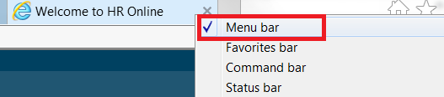

2. Click on **Tools** tab of Menu bar

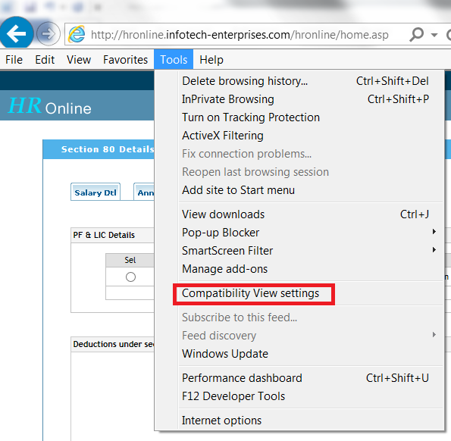

3. You will get a popup window as below in which “**infotech-enterprises.com**” need to **Add** as shown below

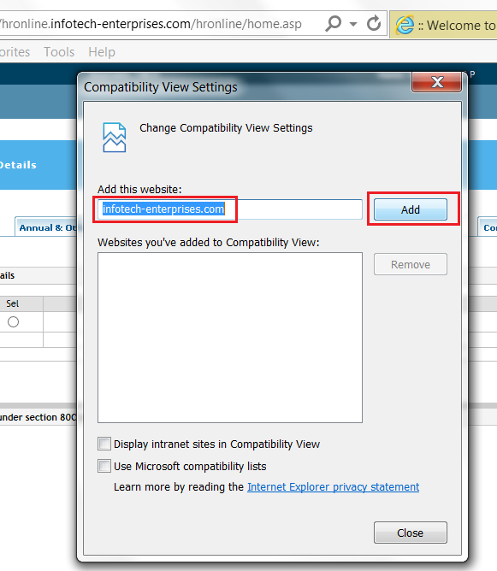

4. You can close the window after adding the website link and checked the check boxes as shown below

